HOMEWORK – 2

Docker

1) Dockerfile

bash-3.2$ cat ~/docker-homework/Dockerfile
FROM python:3.11-slim
WORKDIR /app
COPY hello.py .
CMD ["python", "hello.py"]

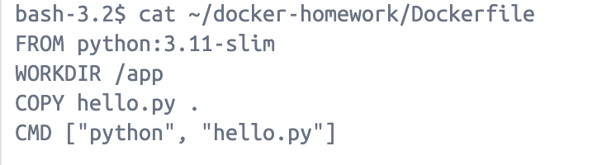

2) Python file = ‘hello.py’

bash-3.2$ cat ~/docker-homework/hello.py
print("=" * 40)
print(" Bitcoin Block Explorer - Docker Test")
print("=" * 40)
print("Docker container is running successfully!")
print("Ready to build the blockchain explorer.")
print("=" * 40)

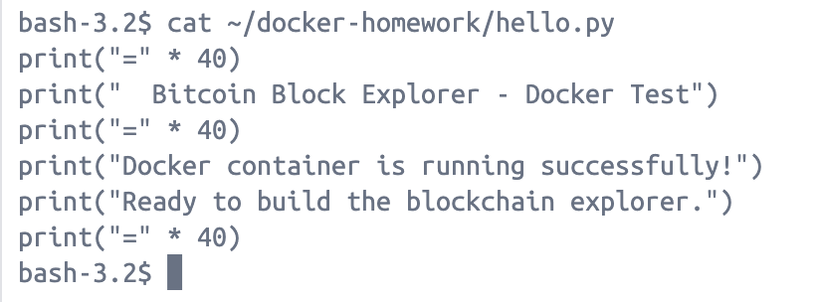

3) Docker running successfully

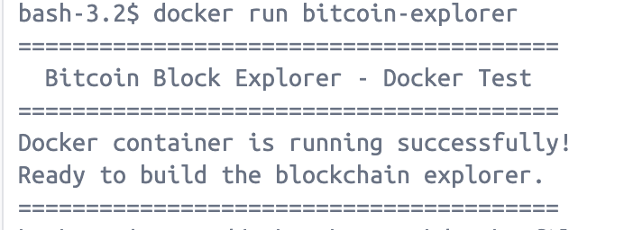

Bitcoind

I have attached the debug.log file and a screenshot of my terminal showing that RPC commands through bitcoin-cli are working perfectly.

OpenAI

So, for the OpenAI part, I used Groq API as an alternative to OpenAI. Groq is a high-performance AI inference platform that provides access to powerful open-source large language models (LLMs). The specific model used is LLaMA 3.3 70B Versatile, which is a state-of-the-art language model developed by Meta.
The Python program implements a Text-to-SQL pipeline using the following steps:
- Schema Definition — A SQL schema is defined using a CREATE TABLE statement for a blocks table, which represents Bitcoin blockchain data containing fields like block ID, hash, timestamp, number of transactions, miner address, and reward.
- Natural Language Question — A plain English question is provided: "What is the total number of blocks in the database?"
- Prompt Construction — The schema and question are combined into a structured prompt that instructs the LLM to generate a SQL query based on the given schema and question.
- API Call — The prompt is sent to the Groq API using the groq Python library, which forwards it to the LLaMA 3.3 70B model for processing.
- SQL Generation — The model returns the appropriate SQL query: SELECT COUNT(*) FROM blocks; which correctly answers the natural language question.
Why Groq instead of OpenAI: Groq was chosen as it provides free API access to high-quality LLMs, making it an accessible alternative to OpenAI for students. The assignment explicitly allows the use of any high-end LLM platform.
